Day 4 - Practical

Manolo Perez

**General Instructions:**

Download all files from the Day 4 shared folder to your Google Drive.

**Practical Exercise 1:**

Go through Section 1 of the script and try to recognize all the elements of the network.

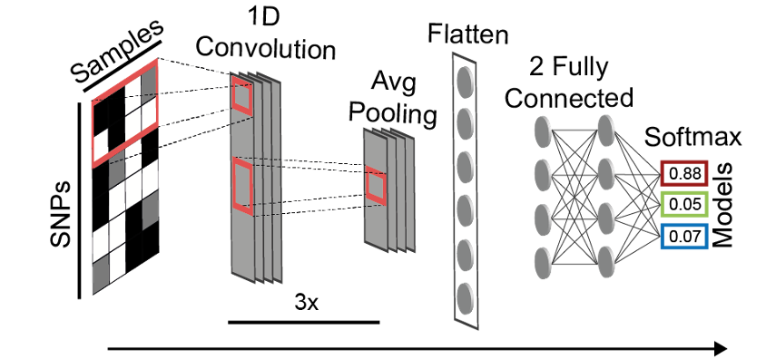

Do you remember the function of each of those elements? Do not forget that you can add annotations to the code using # and add information that might help you when you get back to the script in the future.

Now run all the cells until you reach the end of section 2. Your network will be training, so now we will have some time to discuss and do a quick review on the CNN elements.

**Practical Exercise 3:**



* Scenario 1:

./ms 270 1000 -s 1 -t 0.280081 -I 2 160 110 -n 2 1.875624 -en 0.001289 1 35.544203 -en 0.001289 2 79.531376 -em 0.001289 1 2 1.263896 -em 0.001289 2 1 1.919980 -eg 0.017061 1 38.360445 -eg 0.017061 2 43.970864 -em 0.017061 1 2 0.301733 -em 0.017061 2 1 3.967323 -eg 0.127240 1 0 -eg 0.127240 2 0 -ej 0.293251 1 2

* Scenario 2:

./ms 270 1000 -s 1 -t 0.197474 -I 2 160 110 -n 2 1.881221 -en 0.000138 2 13.295751 -em 0.000138 1 2 3.076617 -em 0.000138 2 1 3.641901 -eg 0.010041 2 23.017965 -em 0.010041 1 2 2.368179 -em 0.010041 2 1 0.699033 -eg 0.130037 2 0 -ej 0.756109 1 2

Scenario 3:

./ms 270 1000 -s 1 -t 0.388039 -I 2 160 110 -n 2 1.378919 -em 0.000606 1 2 3.543538 -em 0.000606 2 1 1.884716 -em 0.006555 1 2 1.994695 -em 0.006555 2 1 3.124491 -ej 0.237054 1 2

Copy the commands in PopPlanner and try to visualize what is being simulated (you can change the Max Time if you need).

Is it difficult to see the scenario in PopPlanner? Do you have any thoughts about why simulations show like that?

Now visualize the segregating sites and the trees using -T >> trees.tre. Can you see a difference in the output of these simulations compared to the simulations from Exercise 2?

Add trees from different scenarios into FigTree and see if you can see any similarities or differences.